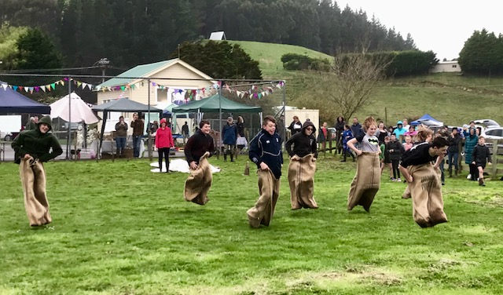
The Reikorangi Residents Association present the Spring Fling! Country Fair – be entertained with Music from 11:30am, enjoy Devonshire Tea and a sausage, Rockets, stalls, plants and produce and lots more. Fun and Prizes to be had! All funds raised will go towards a playground for the reserve.

Time | Activity
11:00 | Gates open
11:15 | Pet Parade
12:00 | Sack Race
12:30 | 3 Legged Race
12:45 | Gumboot Throwing
13:30 | Hat Judging
13:45 | Pony Poo Lotto draw
14:00 | Tug of war
From 11:30 | Music
anytime | Rockets, facepainting, fishing competition

Pet Parade Information
The Pet Parade will be run at 11:15am with two classes:
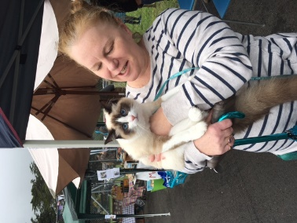
- Class 1: Best Led
- Class 2: Best Presented
Ribbons will be presented for each class. To enter, please email Val Ballinger with your name, your pets name and type of animal so we have some idea of numbers, mandvballinger@gmail.com or phone Val 04 293 7504

Hat Competition
Wear a Spring Themed Hat – win a prize!

